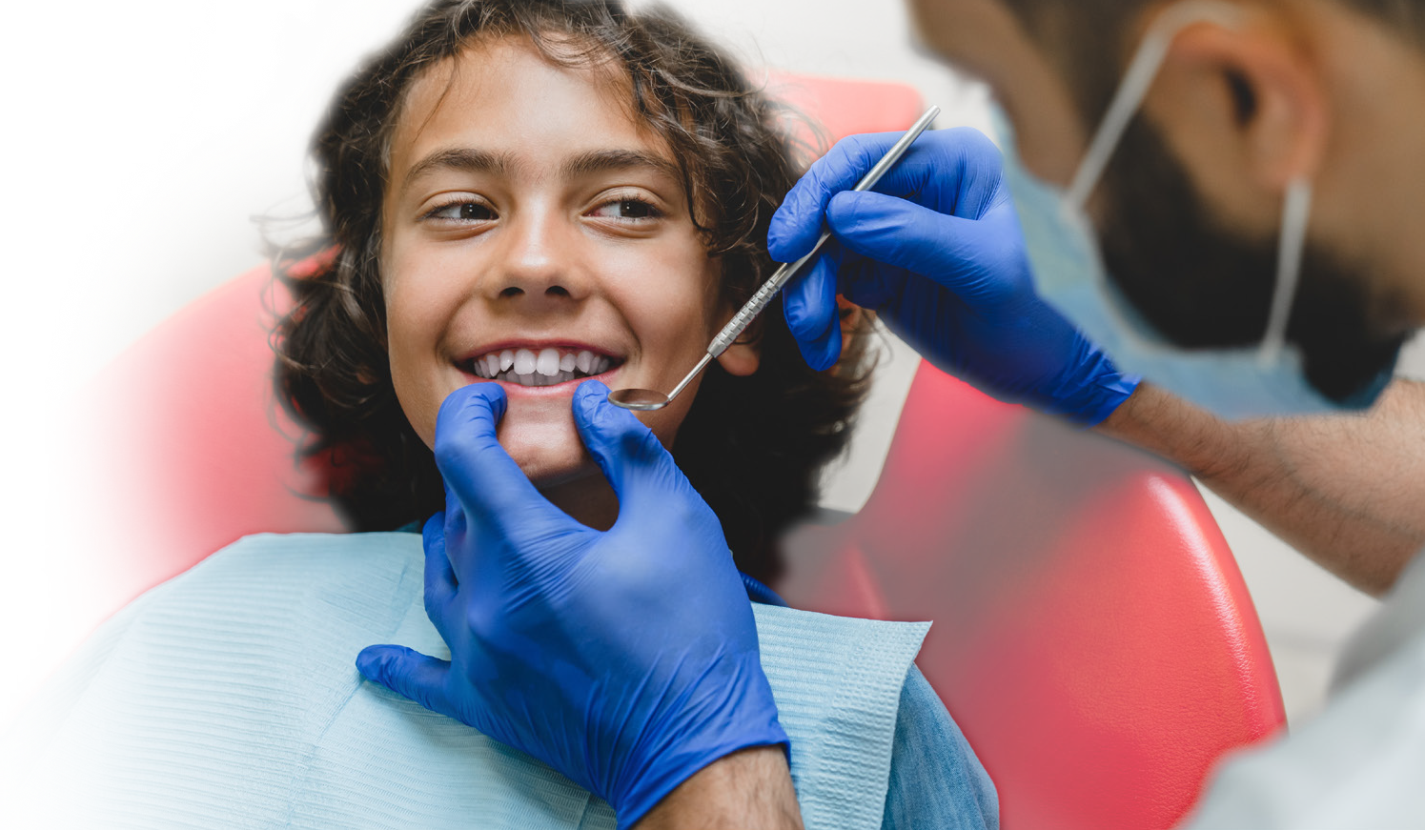

**Free Children’s   
Dental Clinic**in Weaverville

An opportunity for TK–4 students and their   
parents/guardians in Trinity County school   
districts to receive **FREE dental care**from qualified, caring professionals is   
coming this fall.

Good oral health is very important to a child’s well-being. Children need their teeth to eat properly, talk, smile and feel good about themselves. Kids with cavities experience pain and may have trouble chewing and staying focused in school.

in Weaverville

**DATES:**

Wednesday–Saturday

**October 9–12, 2024**

8am–3pm

**LOCATION:**

**Weaverville Veterans’ Memorial Hall**

109 Memorial Drive, Weaverville, CA

**ELIGIBLE PARTICIPANTS:**

**TK through 4th grade students & their parents/ guardians**

(as of 2024–25 school year) who attend schools within Trinity County.

**SERVICES OFFERED:**

* Dental exams
* X-rays
* Minimally invasive dental treatment including fluoride varnish
* Dental fillings and tooth extractions, as needed
* Parents/guardians transporting children from outside of Weaverville can receive a $30 gas gift card while supplies last

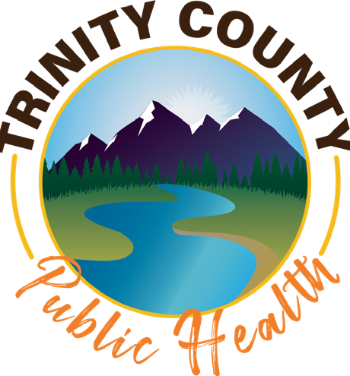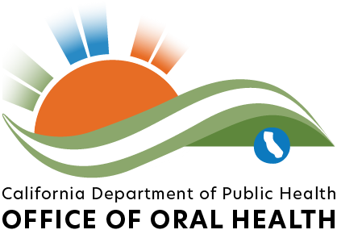

* Dental and health professionals will donate their skills to provide oral health care and education to Trinity County school children and their parents/guardians at no cost.

Email [**myishia.johnson@cda.org**](mailto:myishia.johnson@cda.org)by September 30, 2024 to make an appointment. No walk-ins.